**Normalization Lab**

**1)** **Your task in this exercise is to move the un-normalized table to 3NF. To do this, use the dependency diagram**.

|  |  |  |  |  |  |
| --- | --- | --- | --- | --- | --- |
| Dept# | DeptName | location | Mgr Name | MgrID No | Tel Extn |

**Q1:**

**1NF**

**Department**

Customer-complanment

|  |  |  |  |  |
| --- | --- | --- | --- | --- |
| Dept# | Cust# | CustName | Date of complaint | Nature of  Complaint |

**2Nf**

|  |  |  |  |  |  |
| --- | --- | --- | --- | --- | --- |
| Dept# | DeptName | location | Mgr Name | MgrID No | Tel Extn |

Department

Customer

|  |  |
| --- | --- |
| Cust# | CustName |

Compliant

|  |  |  |  |
| --- | --- | --- | --- |
| Cust# | Dept# | Date of complaint | Nature of  Complaint |

**3NF**

Department

|  |  |  |  |  |
| --- | --- | --- | --- | --- |
| Dept# | DeptName | MgrID No | location | Tel Extn |

Mgr Customer

|  |  |
| --- | --- |
| MgrID No | Mgr Name |

|  |  |
| --- | --- |
| Cust# | CustName |

Compliant

|  |  |  |  |
| --- | --- | --- | --- |
| Cust# | Dept# | Date of complaint | Nature of  Complaint |

********************************************************************************************************************************************************

**2- Employee and Projects**

The table below depicts the requirements for a business consultancy working on local and international projects.

|  |  |  |  |  |  |  |  |
| --- | --- | --- | --- | --- | --- | --- | --- |
| **Emp-No** | **Emp-Name** | **Dept** | **Dept Manager** | **Proj-id** | **Proj-Start-Date** | **Location** | **Weeks-on-Project** |
| 005 | Smith | Marketing | Jones | A  B  C | 12-1993  06-1994  09-1994 | Poole  Plymouth  Portsmouth | 11  15  6 |
| 007 | Bond | Accounts | Bloggs | B  D | 06-1994  06-1994 | Plymouth  Berlin | 3  9 |
| 009 | King | Info Systems | Hurne | C | 09-1994 | Portsmouth |  |
| 010 | Holt | Accounts | Bloggs | A B D | 12-1993  06-1994  06-1994 | Poole  Belfast Hamburg | 1021  10  12 |

Emp.no is the primary key. Employees work on a number of projects concurrently. Weeks-on-project represents the number of weeks that an employee has spent on a particular. The employee number, emp-no, and the project identifier, project-id, are unique identifiers. The department manager, manager, is the name of the current manager, i.e., there can be only one manager per department. A project can take place in several locations (i.e Employees can work on a project from their location). You are required to show the first, second and third normal forms.

**1NF:**

**Employee**

|  |  |  |  |
| --- | --- | --- | --- |
| Emp-No | Emp-Name | Dept | Dept Manger |

**Project**

|  |  |  |  |  |
| --- | --- | --- | --- | --- |
| Proj-id | Emp-No | Proj-Start-Date | location | Weeks on project |

**2NF:**

**Employee**

|  |  |  |  |
| --- | --- | --- | --- |
| Emp-No | Emp-Name | Dept | Dept Manger |

**Project**

|  |  |  |
| --- | --- | --- |
| Proj-id | Proj-Start-Date | location |

**Emp-proj**

|  |  |  |  |
| --- | --- | --- | --- |
| Emp-No | Proj-id | location | Weeks on project |

**3NF:**

|  |  |  |
| --- | --- | --- |
| Emp-No | Emp-Name | Dept |

**employee**

|  |  |
| --- | --- |
| Dept | Dept Manger |

Dep-Mgr

Project

|  |  |  |
| --- | --- | --- |
| Proj-id | Proj-Start-Date | Location |

Work on

|  |  |  |
| --- | --- | --- |
| Proj-id | Emp-No | Weeks on project |

**3- Normalization:**

The following table represents the database of a system that stores data about all Car Companies in Egypt. ***Model ID* is the identifier for each model with a specific color**. *Selling Price* is the price of that model in the specified Company. *Available Quantity* is the quantity of the model in this Company. *Dealer* is the distributer (موزع) of the specified model regardless of the Company. **Company *ID*** is the current **Primary Key** of the table.

**You are required to show the first, second and third normal forms.**

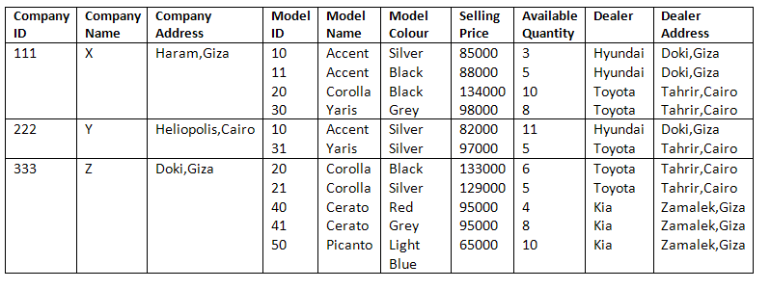

**1NF:**

company

|  |  |  |
| --- | --- | --- |
| Company ID | Company Name | Company Address |

Model-quant

|  |  |  |  |  |  |  |  |
| --- | --- | --- | --- | --- | --- | --- | --- |
| Model ID | Company ID | Model Name | Model Color | Selling Price | Available Quantity | Dealer | Dealer  Adress |

**2NF:**

company

|  |  |  |
| --- | --- | --- |
| Company ID | Company Name | Company Address |

|  |  |  |  |
| --- | --- | --- | --- |
| Company ID | Model ID | Selling Price | Available Quantity |

Company-quantity

Model detail

|  |  |  |  |  |  |
| --- | --- | --- | --- | --- | --- |
| Model ID | Model Name | Model Color | Selling Price | Dealer | Dealer  Adress |

3NF

**company**

company

|  |  |  |
| --- | --- | --- |
| Company ID | Company Name | Company Address |

Dealer

|  |  |  |
| --- | --- | --- |
| Model ID | Dealer | Dealer  Adress |